Project Info

Used technologies:

JDK-14.0.2 => https://www.oracle.com/java/technologies/javase-jdk14-downloads.html

Apache maven 3.6.3 => https://maven.apache.org/install.html

postgres 12.3 => https://www.postgresql.org/download/windows/

node 12.18.2 => <https://phoenixnap.com/kb/install-node-js-npm-on-windows>

Loaded users info

|  |  |
| --- | --- |
| UserName | Password |
| Admin | admin |
| User1 | user1 |
| User2 | user2 |
| User3 | user3 |

after doing all setup of BE and FE   
  
Step1: access <http://localhost:3000>

Step2: log in by user : Admin, pass: admin

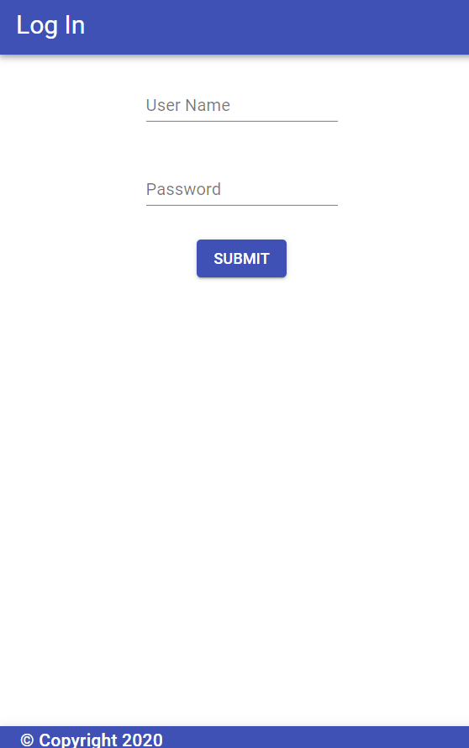

Step3: Admin View:

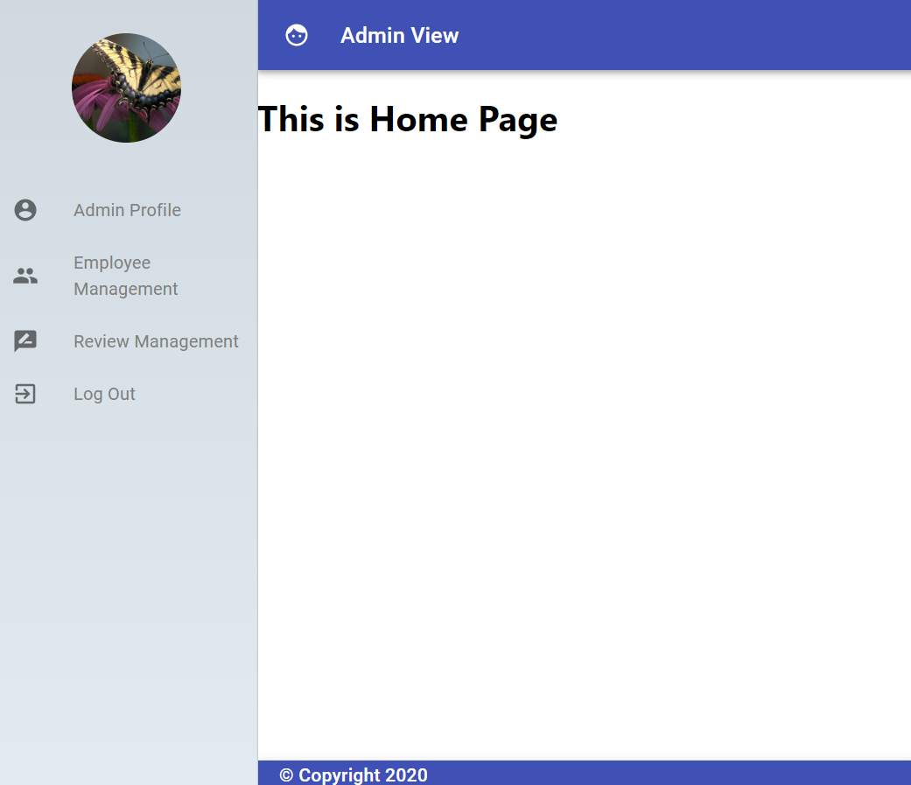

Step4: Click Employee Management:  
  
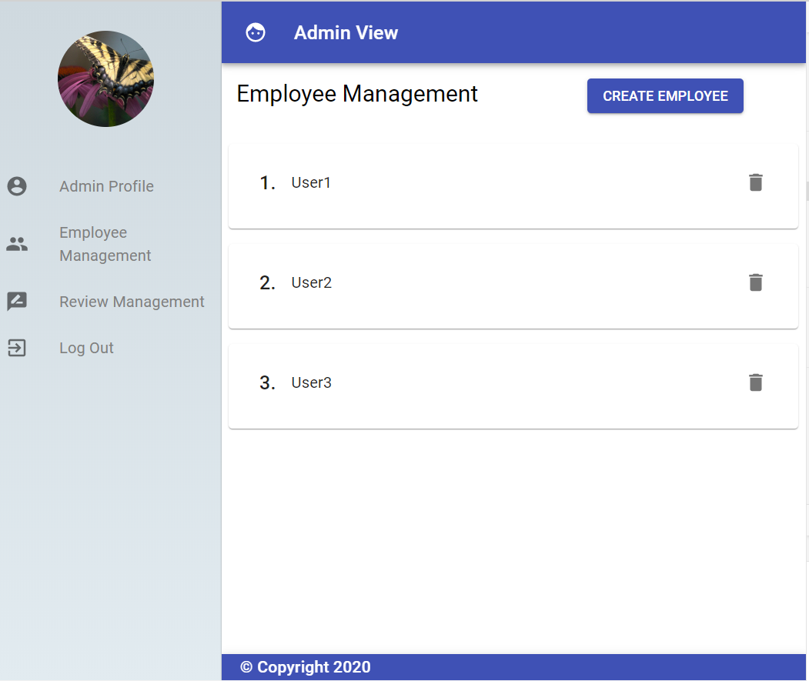

Step5: Employee Info

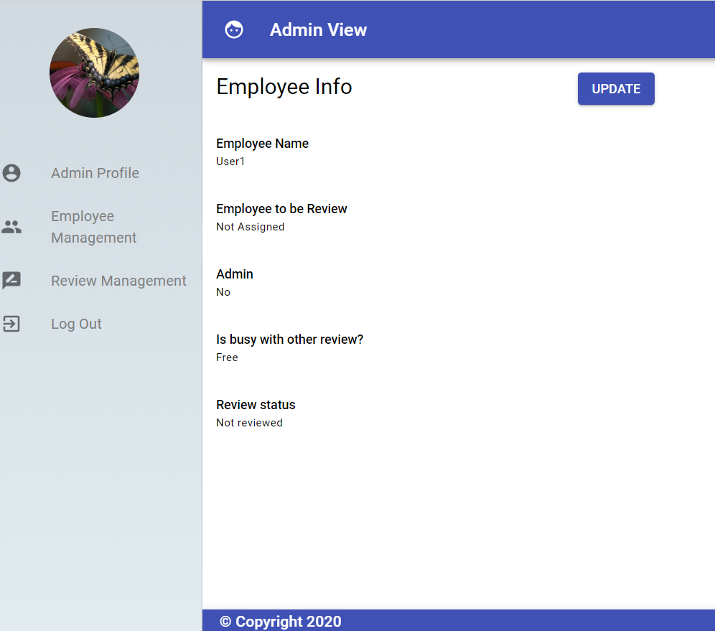

Step6: Click Review Management

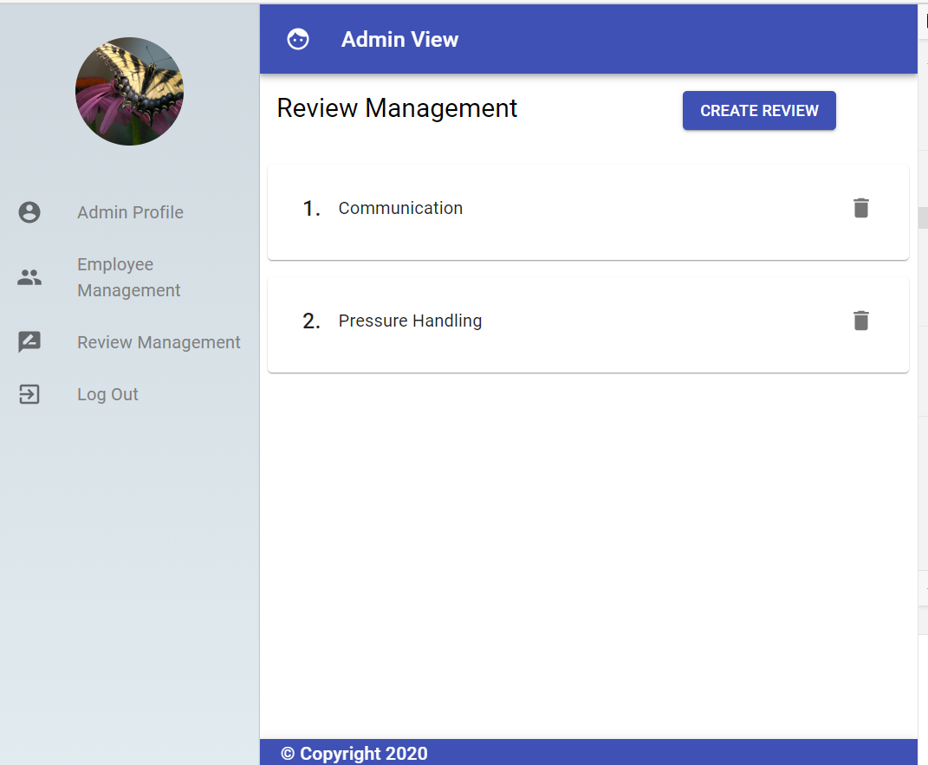

Step7: Review details  
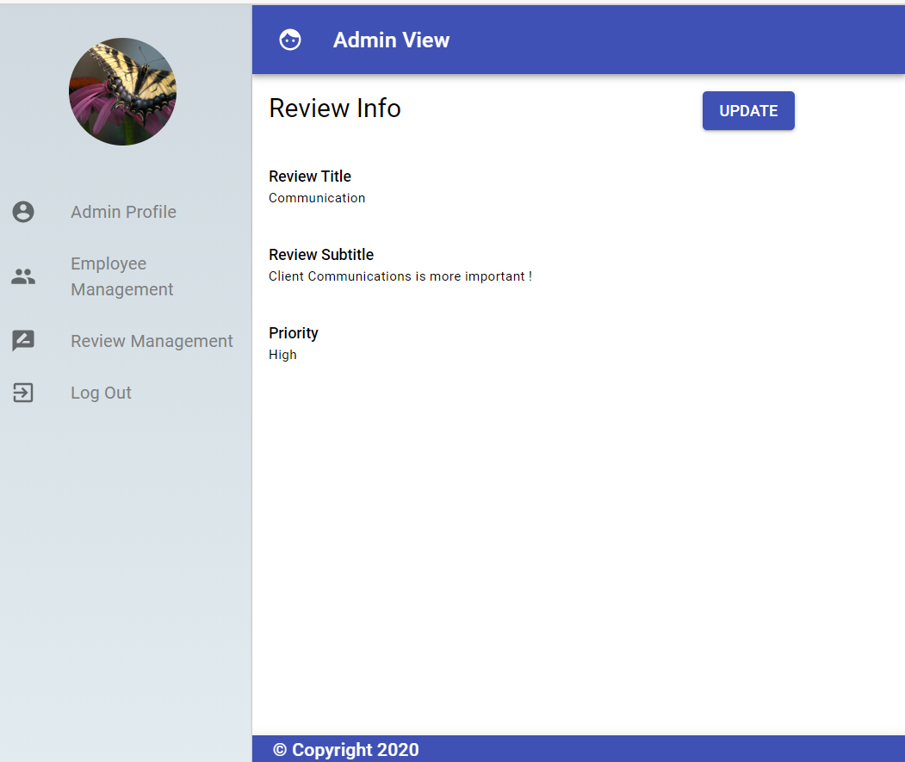

Step8. Click employee management and click on one of the employee.

Then click update employee.  
Please select Employee to be review.

And submit.

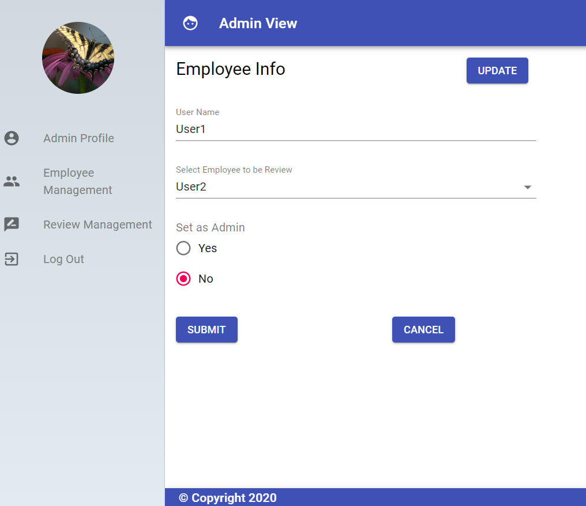

Step9: Logout:  
  
Step 10: Login by updated user (in above case user is User1 with password user1)  
This is Feedback screen   
  
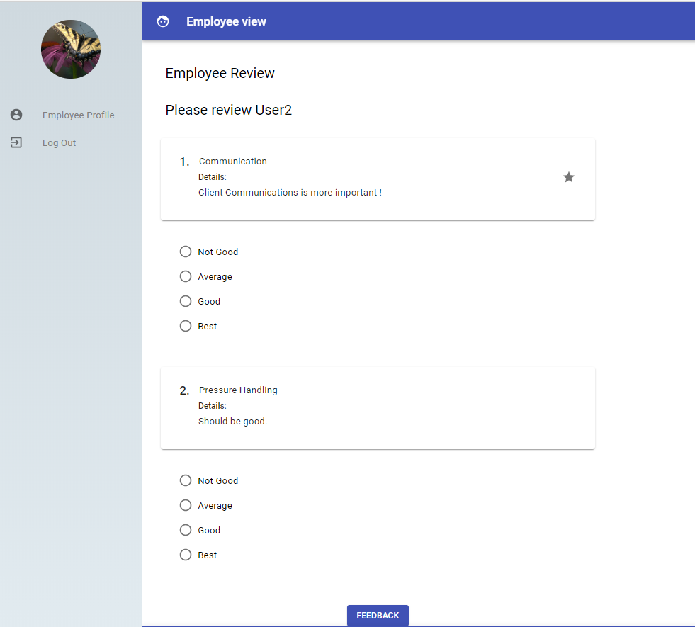

Step11: after submitting feedback  
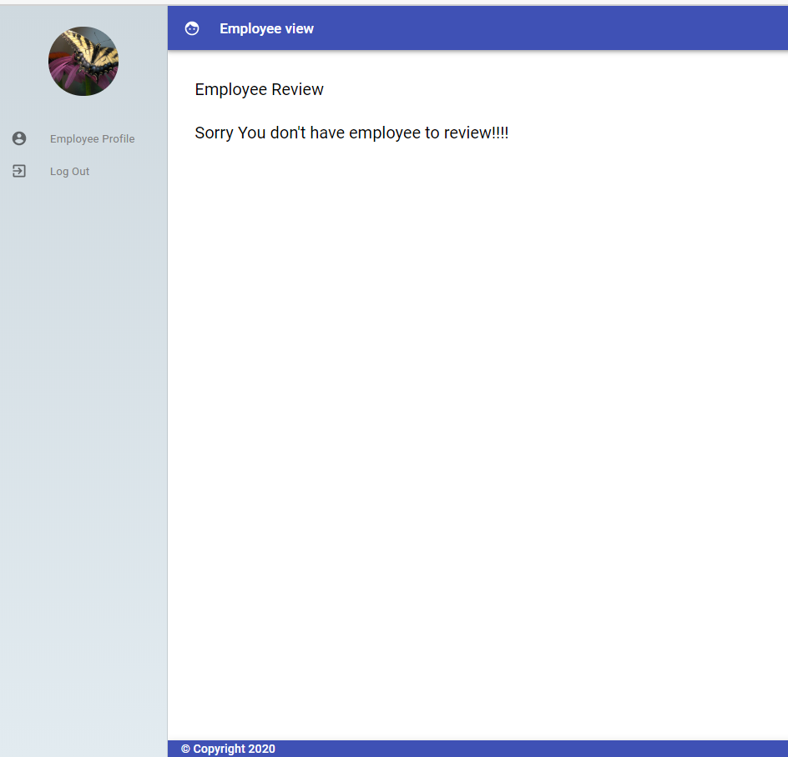

Step12: You can go to Admin page and check status of employee,  
In this case User1-> reviewer and User2-> reviewed employee.

User1: After review  
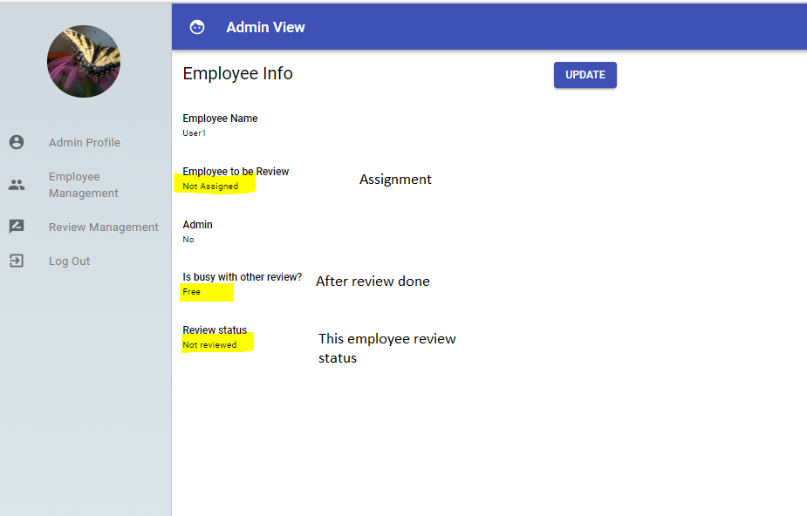

User2: After review

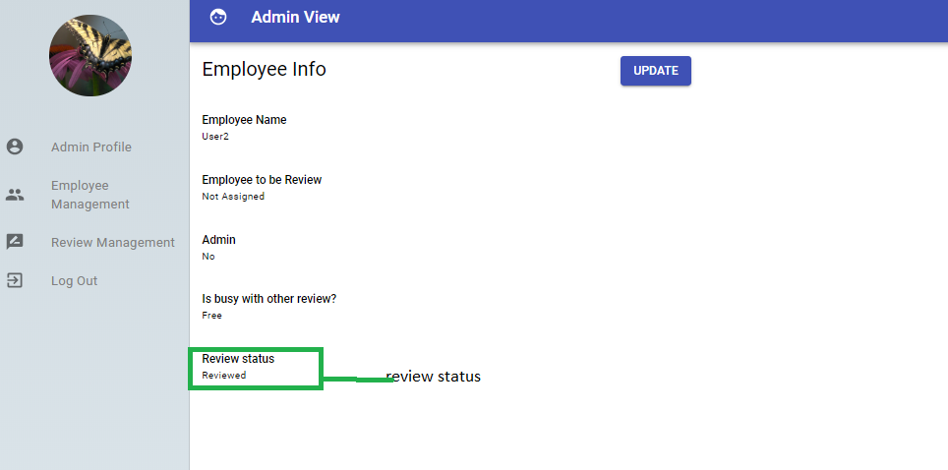

Below things are pending due to time constrains.  
  
1. User Authorizations (spring boot authorization with jwt)

2. Now can assign only one employee for review but plan was to assignment of multiple employee at a time.

3.Review management screen can be improve in future.